Project Design Phase-II

Technology Stack (Architecture & Stack)

|  |  |
| --- | --- |
| Date | 15 November 2022 |
| Team ID | PNT2022TMID48496 |
| Project Name | Project – Smart Farmer- IOT Enabled smart farming Application |
| Maximum Marks | 4 Marks |



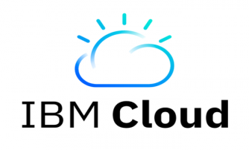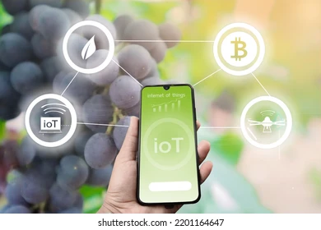

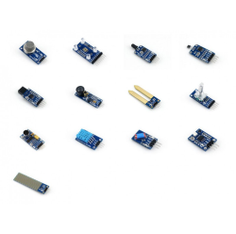

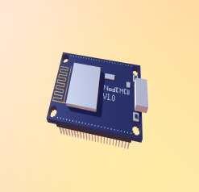

**SENSOR**

**Node MCU**

All of the sensors (including the humidity sensor, motion sensor, hazardous gas sensor, and soil temperature and moisture sensors) are calculated and their results are stored in the IBM cloud.

The sensor values are computed by the microcontroller board (Node MCU) and stored in the cloud for display to the user.

In order to write the hardware, software, and APIs, NODE-MCU is utilised as a programming tool.

A mobile application provides the user with all the info. The user may control the motor and other important devices by using the appl

Table-1 : Components & Technologies:

|  |  |  |
| --- | --- | --- |
| Component | Description | Technology |
| 1. User Interface | Interaction with application. | Android |
| 2. Application Logic-1 | Logical Data Operation And Sourcing. | C |
| 3. Application Logic-2 | Application Processing. | IOT service |
| 4. Application Logic-3 | Application Processing. | IBM Assistant |
| 5. Cloud Database | Database Service on Cloud | IBM Cloud |
| 6. File Storage | Storage Sources | IBM Block Storage or Other  Storage |
| 7. External API-1 | Used in the application For Weather | Open Weather API |
| 8. Infrastructure (Server / Cloud) | Application Deployment on Local System / Cloud Local Server Configuration:  Cloud Server Configuration: | Local, Cloud Foundry. |

Table -2: Application

|  |  |  |  |
| --- | --- | --- | --- |
| S.No | Characteristics | Description | Technology |
| 1. | Open-Source Frameworks | The open-source frameworks used | Technology of Open source framework |

|  |  |  |  |
| --- | --- | --- | --- |
| 2. | Security Implementations | In this private data must be protected | Node- MCU weather App, App Inventor |
| 3. | Scalable Architecture | Scalability plays an Important Role for IOT platforms. The real time decision-making is feasible in environment composed of dozens of Data’s. | IBM Cloud And Related Technologies. |